Sparkle Diamonds Project ERD Creation
DBM/380
Learning Team

Learning Team: Sparkle Diamonds Project
The first part of the process was to determine what data table relationships, field attributes, fields, and tables would be needed to develop a database to support the Sparkle Diamonds sales team. Next, an Entity Relationship Diagram (ERD) is needed that mirrors the relationships and tables used in the Sparkle Diamonds Database Project. Since the sales team needs the inventory to query various specifications of diamonds, an ERD must show tables for customers and inventory, as well as the following information about the diamond specifications of cost, price, carat, clarity, cut, color, and ordering tables.
These are the main tables that can support the necessary queries to create Sales Orders, check Inventory status, and ship to multiple customer locations. Orders start with a client, so the first table layout was to support the customer information required to make a purchase, ship it out, create a Sales order, and replenish inventory when it starts to run low.
The CustomerInfo table includes the following columns: CustomerID (Primary Key), ShipLocID (Foreign Key), Cust_Name, Cust_Addr1, Cust_Addr2, Cust_City, Cust_State, Cust_ZipCode, Cust_EmailAddr, and Cust_PhoneNum, which are all necessary to support the database design. Recognizing customers can have multiple shipping addresses, a ShippingInfo table was needed to contain ShipLocID (Primary Key), Ship_Desc, Ship_Addr1, Ship_Addr2, Ship_City, Ship_State, and Ship_ZipCode for the delivery of the diamonds.
The next process was determining the needed details for the ordering process. Details such as what customer is placing the order, order date, and shipping complete could be considered one order while the product(s) ordered could be multiple, so the order information table was decided to be separate from the order products information, to support the sales order requirement.
The Team created an SalesorderInfo table with SalesorderID (Primary Key), CustomerID (Foreign Key) to support the relationship to the CustomerInfo, SalesorderDate, EstShipDT, Shipped?, ActShipDT, and ProductID to support the relationship when creating a Sales Order to the actual product that was sold so that it can contain the description of the diamonds. The products ordered information can have multiple records, but should relate to only one placed Salesorder. Thus, the ProdInventory table was created to house the information about each diamond that is sold to customers. Additionally, three more tables are needed that contain information including the Clarity table, Cut table, and Color table to support a more normalized database design.
The final design supports the sales team’s need to create sales orders and check inventory status. The ProdInventory table has a relationship to the SalesorderInfo table via the ProductID (Primary Key) and the SalesorderID (Foreign Key). This serves two purposes, including inventory count queries and sales order processing. The ProdInventory table also contains ProductDesc, ProductCost, ProducePrice to support the sales order requirements. The inventory count queries are supported with columns including: QtyTotal, QtyStock, QtySold to query to current Inventory Report for the sales team, as well.
The data types allow for the entry from a list of choices, however it must be specific to the kind of database you will be using (i.e., SQL, Microsoft Access, etc.). Also, with this database design, there are three attributes in the ProdInventory table, to be set as lookup or choice attribute types, including Clarity (Foreign Key), Cut (Foreign Key), and Color (Foreign Key) so that accurate product descriptions can be obtained during a query, or either a sales order or an inventory report.
Additional LookUp Tables Needed
Clarity
ClarityID | Primary Key
Clar_IF | Internally Flawless
Clar_SSV1 | Very, very slightly included (Pavillion)
Clar_SSV2 | Very, very slightly included (Crown)
Clar_SV1 | Very slightly included (under 10x magnification)
Clar_SV2 | Very slightly included (to the naked eye)
ProductID | Foreign Key
Table 1. Clarity Table (2017).

Cut
CutID | Primary Key
Cut_E | Excellent
Cut_VG | Very Good
Cut_G | Good
ProductID | Foreign Key
Table 2. Cut Table (2017).

Color
ColorID | Primary Key
ProductID | Foreign Key
Color_D | D-Colorless
Color_E | E-Colorless
Color_F | F-Colorless
Color_G | G-Near colorless
Color_H | H-Near colorless
Color_I | I-Near colorless
Color_J | J-Near colorless
Table 3, Color Table (2017).
Using Microsoft Visio to set-up, the ERD was a relatively difficult and complicated process, especially attempting to make the program put the correct crow’s feet notation and foreign key symbols.
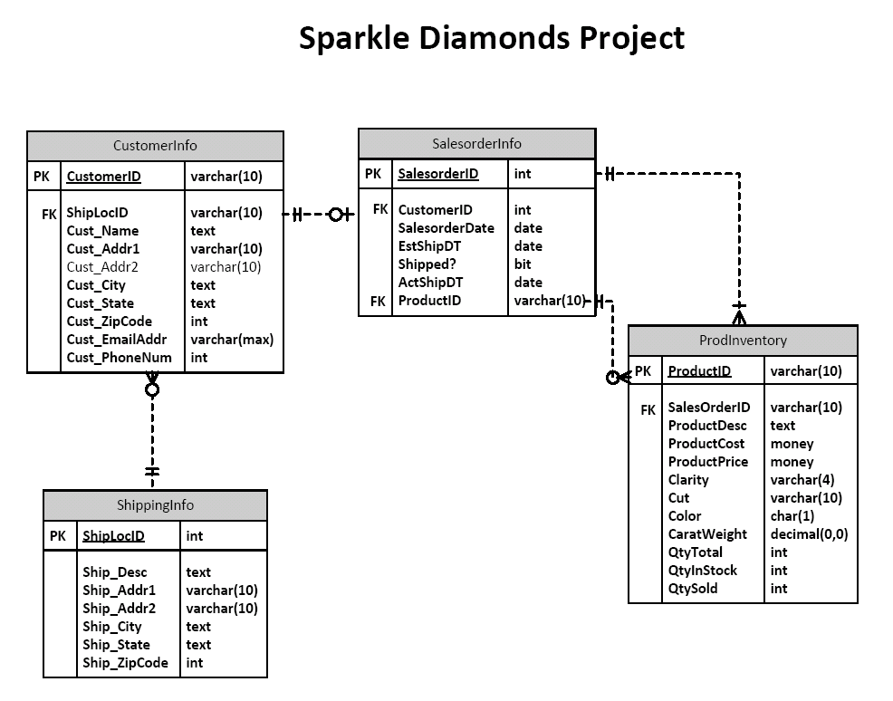
Figure 1. Sparkle Diamonds Entity Relationship Diagram (2017).

Reference Page
Coronel, C., Morris, S. (2017). Database systems: Design, implementation, & management. (12th ed.). Cengage.
Web3Schools.com (2017). SQL Data Types for Various DBs. Retrieved from https://www.w3schools.com/sql/sql_datatypes.asp

